

***DEPARTMENT OF COMPUTER ENGINEERING***

**Experiment No. XX**

|  |  |
| --- | --- |
| Semester | B.E. Semester VII – Computer Engineering |
| Subject | Soft Computing |
| Subject Professor In-charge | Prof. Amit K. Nerurkar |
| Assisting Teachers | Prof. Amit K. Nerurkar |
| Laboratory |  |

|  |  |  |
| --- | --- | --- |
| Student Name |  | |
| Roll Number |  | |
| Grade and Subject Teacher’s Signature |  |  |

**Title: (PRINTED)**

**Objective:** **(PRINTED)**

**Pre Lab/ Prior Concepts: (PRINTED)**

**New Concepts to be learned: (PRINTED)**

**Explanation/ Stepwise-Procedure/ Algorithm:**

**(HANDWRITTEN)**

**Program Code: (PRINTED)**

**Output:**

**Screenshots:**

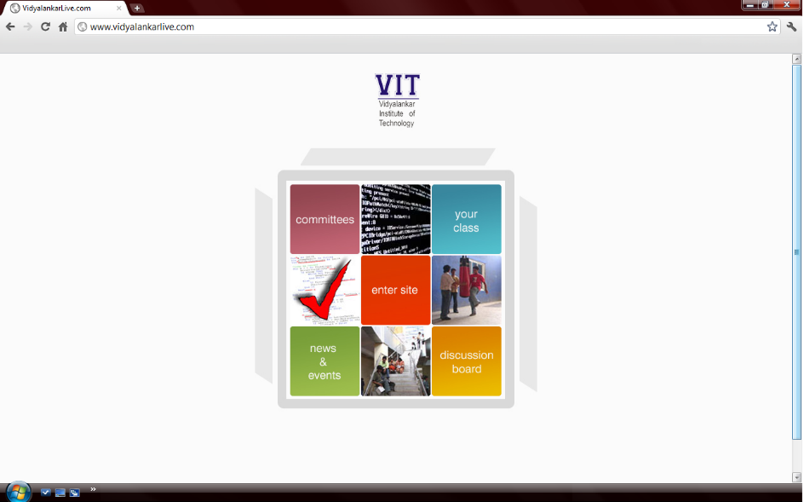

**Conclusion: (PRINTED)**